Session 5

DML + JOIN
- UPDATE
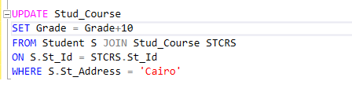
- DELETE
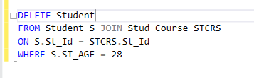

Functions
- Built-in Functions
- User-Defined Functions

Built-in Functions:
- Aggregate Functions (COUNT, SUM, AVG,MAX,MIN)
Normally Agg Functions doesn’t see null (Skip nulls)
Also check the documentation as there is more variants for bigger data
Ex COUNT() has a variant which is BIGCOUNT()
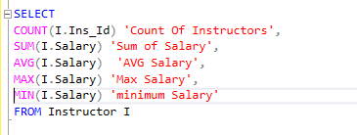
- Null Functions
IsNull(“Expression”, Replace Values | Agg Functions )
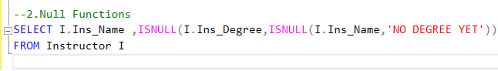
Note: the data type that is returned in returned as the same datatype as the column but with the “NOT NULL” Constraint
Coalesce(expression [ …, n ]) More Readable
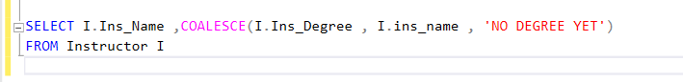
Note: the data type that is returned in returned as the same datatype as the column but with the “NULL” Constraint
Note: The Replace value must be the same Data type as the expression or the value should be convertible to the datatype of the expression
- Date & Time Functions
SYSDATETIME()
Return system date time of the server or the machine that the database instance installed on it ,with the datatype of DATETIME2(7)
SYSUTCDATETIME()
Same as SYSDATETIME but it gets me the UNIVERSAL TIME
GETDATE()
Return the system date and time
GETUTCDATE()
A variant but returns the universal time
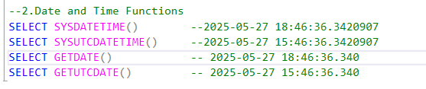
DATENAME()
Functions used to specify a part of the date that is sent
and this functions returns character string
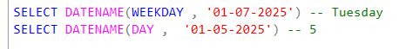
DATEPART()
same as DATENAME() but it returns integer representing specific part of the date
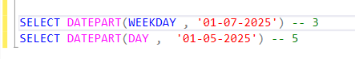
DAY() , MONTH() , YEAR() self-described at this point
EOMONTH() Gets last day of the month of the date
ISDATE() A validation functions for checking on a value to see if it is a valid date or not
- Conversion Functions
CAST & CONVERT
they are the same the only deference is the syntax and the convert functions got 1 more parameter which is style
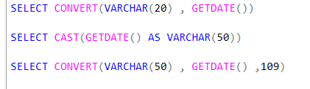
PARSE
used only to convert from string to date/time and numbers
TRY_CAST, TRY_CONVERT ,& TRY_PARSE
Variants but with exception handeling
String Functions
CONCAT()
does automatically convert any non-string value to string and concat them all together but without spaces or separations
CONCAT_WS()
Same as concat but it does take the first parameter as a separator between the parameters
LOWER() & UPPER()
Self Explained
Len()
return the length of the string as INT datatype
SubString()
3 parameters (Value , start index , end index)
Format()
Convert any convertible value to string and return that string with a specific format and optional calture
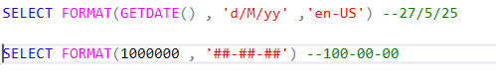
GROUP BY
Group By Rules :
1-You can’t Group By with *
2- Grouping by Primary key doesn’t affect any thing
3-we do group by with repeated values
4-if you select column with agg functions you must group by with the same columns
Group By vs Partition By
Group By
we use it when we want to get the summary of aggregate functions result to each group
so group by compress the result of each group in one row that row will be a row that describe that group
partition by
will perform the aggregate function result and the value in a column next to the row that in the same partition as this value

